BioLink: software for managing biodiversity information

BioLink: software for managing biodiversity information 1
Information items and tools 1
Collection Sites or Localities 2
Collecting Events 2
Specimens/Observations 2
Traps and Bulk Samples 2
Managing complexity 4
Inside BioLink: technical details 4
BioLink credits 4
Starting BioLink 6
Logging into BioLink 6
Entering a username and password 6
Selecting a data source 6

BioLink: software for managing biodiversity information
The BioLink system is used to collect, maintain, analyse, apply and disseminate biodiversity information. It is designed to provide easy-to-use tools for researchers and curators in a range of activities who work with taxon-based information and field-collected specimens. ‘Ease of use’ is a guiding principle across the entire BioLink system. We believe that researchers should spend their time and energy doing science, not learning complex computer packages. We believe BioLink achieves this by providing rich, intuitive and easy to learn tools that hide much of the complexity of the data being managed.

Information items and tools
BioLink is a set of integrated, Windows-based programs that manage both taxon- and specimen-based biological information. It is designed to manage this information from initial collection through analysis and maintenance to publication. Major information elements and tools include the following:

Taxon-based information
This information applies to entire taxa rather than individual specimens of a taxon. It is the kind of information commonly found in revisions and monographs.
- Valid (zoology)/Accepted (botany) Name
- Available Name (zoology)/Basionym (botany)
- Literature (zoology)/Valid (botany) Name
- Classification
- Nomenclature/Type Data
- Common Names
- Political Distribution
- Literature References
- Images/Sounds/Multimedia/Digital Information
- Associates
- User-defined Traits and Notes

Specimen-based information
This information is derived from specimens or observations of specimens. It is commonly associated with museum or collection based material and is frequently reported in lists of material examined.

Collection Sites or Localities
- Political Region
- Locality Description
- Geographic Position (Latitude/Longitude or UTM/Map Grids)
- Elevation or Depth
- Geological Details
- User-defined Traits and Notes

Collecting Events
- Collectors
- Collector’s Field Number
- Dates and Times (Single or Period)
- Casual Dates
- User-defined Traits and Notes

Specimens/Observations
- Accession, Registration and Collector’s Numbers
- Collection Method
- Macro- and Microhabitats
- Abundance
- Data Source Type
- Institution
- Identification (Current and Previous)
- Number of Specimens, Gender and Life Stage
- Specimen Subparts and Multiple Specimens
- Original Label Text
- Storage Location and Storage Method
- Condition and Curation Status
- Associates
- Curation Events
- Specimen Label Details
- User-defined Traits and Notes

Traps and Bulk Samples

Collection-management information
This information is used primarily by museum and collection managers when curating collections.
- Accession, Registration and Collector’s Numbers
- Specimen Storage Method
- Specimen Condition and Curation Status
- Specimen Curation Events
- Lot and Bulk Sample Details
- Identification History
- Specimen Label Details
- Taxon and Specimen User-defined Traits and Notes
- Loans
- Loan and Permit Numbers
- Borrower, Receiver and Authoriser Details
- Name and Title
- Job Title
- Institution
- Street and Postal Address
- Work/Home/Fax Phone Numbers
- Email Address
- Transfer Method
- Date Initiated and Date Due
- Partial Returns
- Loan Conditions
- Description of Material (Specimen- and Taxon-based)
- Automatic Loan Forms
- Correspondence Record
- Reminders and Action Dates
- User-defined Traits and Notes
- Label Manager

Reports
A number of predefined reports are included, as well as a generic query tool and report editor.
- Sites for Taxa
- Taxa for Sites/Regions
- Material/Specimens For Taxon
- Taxon Statistics
- Taxonomic Checklist
- Specimen Labels
- Data Entry Statistics
- Query Tool
- Distribution Map
- Material for Lot/Bulk Sample/Trap

Tools
A series of tools are included to assist with information management and analysis.
- Reference Manager
- Multimedia Manager
- Journal Manager
- Phrase Manager
- Trait and Note Types
- Electronic Gazetteer
- Mapping Assistant
- User Manager
- Specimen Loan Manager
- Predictive Distribution Modelling Tool

Data import
A specific import module has been included to assist with transfer of data into BioLink.
- Import Wizard

Data transfer
An externally-accessible XML-based data file can be created for subsets of a BioLink database.
- XML I/O

Managing complexity
One of the primary goals of BioLink is to make managing complex biological information as simple as possible. To achieve this, BioLink uses Explorers to graphically manage taxon names and collection material. These Explorers contain a full list of all items in a database organised hierarchically. They also include a find facility for locating items anywhere within a database and a ‘favorites’ facility to quickly and easily retrieve commonly used items. These facilities make managing large amounts of data with complex relationships a simple and straightforward task.
New in version 3.0 is the Pin Board, which acts as a kind of “global favorites”. Favorite Taxa, Sites, Visits, Material, References, Journals and Place names can be “pinned” for subsequent access or referencing.
The Explorers provide a wide range of features for entering and maintaining information. For example, the classification of taxa is easily modified through ‘drag and drop’. This includes changing ranks (for example when changing a subspecies to a species), creating synonyms by combining taxa, and changing classification (for example, changing generic assignments). New taxa are added directly to the Explorer using the current classification, thus minimising the misspelling of taxon names which would otherwise need to be entered many times (for example, generic names entered separately for each species in the genus).
Explorers also provide direct access to many BioLink functions. For example, detailed information about an item can be retrieved simply by selecting it and choosing a menu command. Generating a distribution map for a taxon is as easy as selecting the taxon and choosing the Distribution Map command. This will automatically retrieve all material for the taxon (and any of its children, if applicable), open the Mapping Assistant, load the material records and display a customisable map. There is no need to generate intermediate files or use a stand-alone GIS or mapping tool. This is only one example of the flexibility and integration provided throughout BioLink.

Inside BioLink: technical details
The following is an overview of the development methods used within BioLink. As with most software, it is not necessary to understand the internal workings of the program to use it effectively and this information is provided for those interested in software engineering as well as biology.
Version 3.0 of BioLink is written entirely in C# leveraging Microsoft’s .Net Framework version 4.0. BioLink uses Microsoft SQL Server to store information, and data access is achieved via ADO.NET. Almost all database interaction is achieved via stored procedures (unchanged from version 2.5), which aids performance and security. BioLink version 3.0 makes use of some third party open source software, namely Avalon Dock (docking library) and SharpMap.NET (mapping tool).

BioLink credits
BioLink was originally developed by the Biodiversity Informatics Team of CSIRO Entomology between 1997 and 2002. The following people were involved in these activities:
Administration
Steve Shattuck (Biodiversity Informatics Team Leader)
Development team
David Baird (Software Design and Programming)
Natalie Barnett (Technical Support)
Darren Biskup (Programming, Ver. 2.0)
Neil Fitzsimmons (System Design and Programming)
Jackie Hooper (Technical Support and Programming)
Ian Reid (Programming and Technical Support, Ver. 1.0, 1.5)
Steve Shattuck (Project Management, System Design and Documentation)

eGaz Ver. 1.0 was designed and developed by Steve Shattuck. eGaz Ver. 2.0 was developed by David Baird (with a little help from Steve). The eGaz documentation was prepared by Steve Shattuck and Natalie Barnett. The eGaz gazetteer files were prepared by Steve Shattuck, Natalie Barnett and Ian Reid. The Mapping Assistant components and map files were prepared by Ian Reid (with help from David). The BioLink Getting Started and User’s Guide documentation and on-line help were prepared by Steve Shattuck.
Ebbe Nielsen provided guidance and unwavering support for BioLink until his death in March, 2001. He still provides unmatched inspiration and enthusiasm which we draw on daily.

The redevelopment of BioLink (Version 3.0) was funded by the Atlas of Living Australia in 2010. The Atlas of Living Australia is an initiative to improve access to essential information on Australia’s biodiversity by providing tools for researchers and others to access, combine and map data on Australian species. The Atlas project is a partnership between the Commonwealth Scientific and Industrial Research Organisation (CSIRO), the Australian natural history collections community and the Australian Government. Development work was carried out by David Baird, under guidance from Steve Shattuck, and technical advice from Robyn Meier.

Starting BioLink

Logging into BioLink
BioLink is designed for use in a multi-user environment. Because of this a username and password must be provided when starting BioLink. Additionally, a data source must be specified. This data source can be on the local machine, a local area network (LAN) or the internet.

Entering a username and password
When BioLink is first started, you will be greeted by a screen that looks something like below:
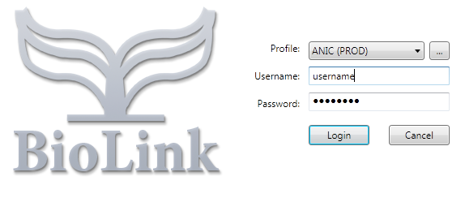
Your system administrator assigns your username and password. Enter these into the appropriate boxes on the Login window.

Selecting a data source
In most cases, your system administrator will establish data sources. If this is the case, a source can be selected from the Source drop down list box and the OK button pressed. This will start your BioLink session. If the required data source is not listed, or there are no data sources to choose from, click the Ellipsis button (with the three dots) next to the Source field to create a new one. This will open the BioLink Source Profiles window.
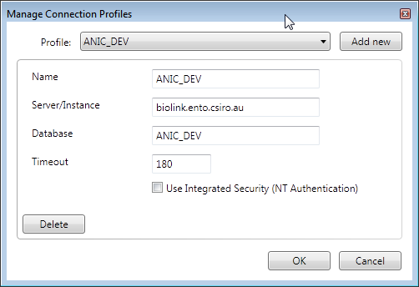
Press the Add New button and enter a new name in the Name field. Enter the name the Database server (using either their network names or IP addresses), the name of the database to connect to. The Database server is the computer holding the database (this will be blank if the database is on the local machine or the name of another computer if a network is being used). To change an existing Source, select it from the dropdown list at the top, and edit its properties in the fields below. To save changes press the OK button. The newly entered or modified profile can then be selected from the Source list on the Login window.
Once a username and password have been entered and a data source specified, clicking the Login window’s OK button will start BioLink. Once started, the main BioLink window will appear.
